# Scikit-learn

<https://scikit-learn.org/stable/>

Scikit-learn is regarded as a simple and efficient tool that one can use for predictive data analysis. Scikit-learn provides one with the opportunity to engage in machine learning within the programming language of python.

Classification: Identifying which category an object belongs to.

Regression: Predicting a continuous-valued attribute associated with an object.

# W3schools machine learning tutorial

Machine learning is making the computer learn from studying data and statistics.

It is a step into the direction of artificial intelligence.

It is a program that analyses data and learns to predict the outcome.

# Datacamp tutorial

<https://www.datacamp.com/tutorial/machine-learning-python>

## Exploratory data analysis

Takes place after reading in the dataset

<https://campus.datacamp.com/courses/supervised-learning-with-scikit-learn/classification-1?ex=1>

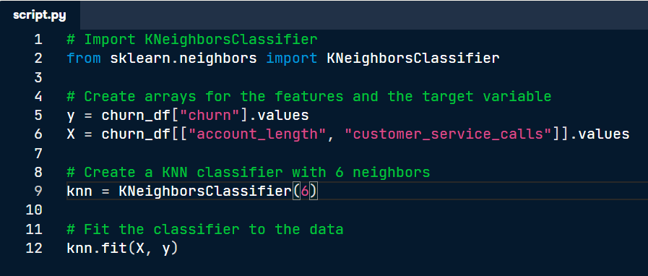

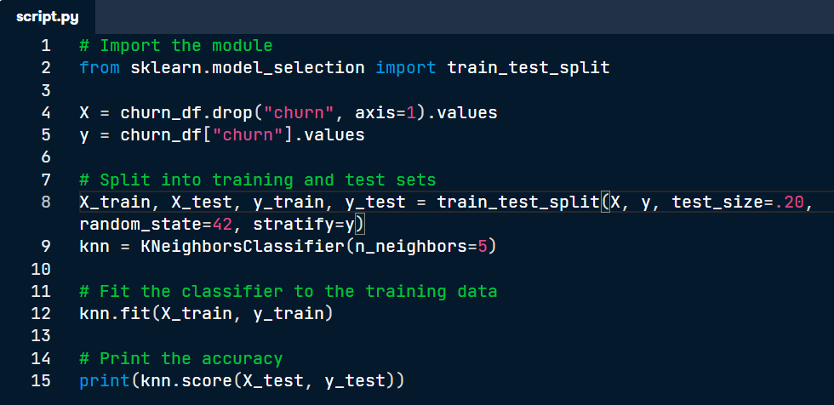

# Data camp course machine learning with scikit-learn

## Classification

### KNN Classifier

### KNN Making a prediction on a non-labelled piece of data

### Measuring model performance

### Train/test split

## Regression

### Reshaping

Loss function

The above code is based on the boston house dataset

### Fit & predict for regression

### 5 fold cross validation

### Regularized regression

Often hearing this term – fit on the training predict on the test

## Part 3 Fine-tuning your model

### Confusion Matrix

### ***\*Logistic regression is used with classification***

### Logistic regression

### Logistic regression – ROC curve

### AUC computation

### Hyperparamter tuning with gridsearchCV

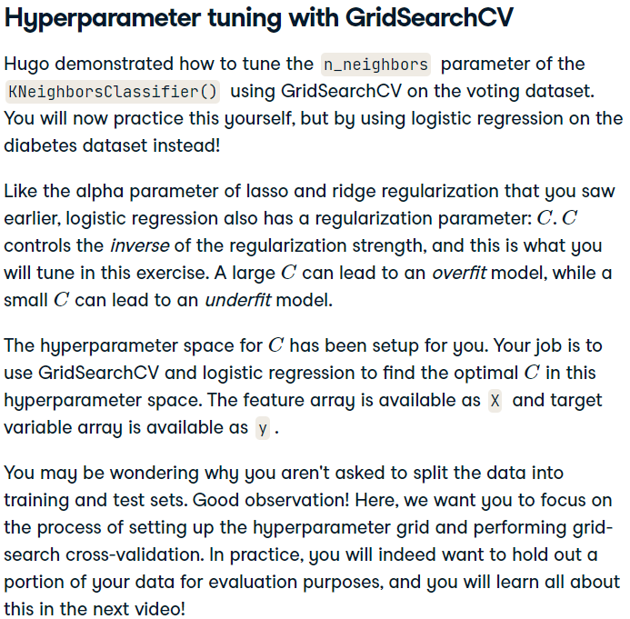

### Hyperparameter tuning with RandomizedSearchCV

### Hold-out set in practice I: Classification

### Hold-out set in practice II: Regression

## Preprocessing Part 4 Pipelines

### Exploring categorical features

### Creating dummy variables

### Regression with categorical features

### Dropping missing data

### Imputing data

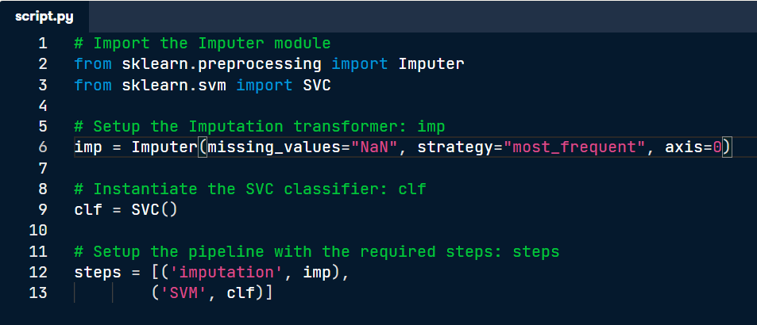

### Centering and scaling

### Centering and scaling in a pipeline

### Brining it all together pipeline for classification

### Brining it all together pipeline for regression

# **Common Process**

## Imports

## Instantiate the classifier

## Spilt data into training and test sets

## Fit the model on training

## Predict on the test set

# Kevin Jolly - Machine Learning with Scikit-learn Quick Start Guide

Kevin Jolly (2018) *Machine Learning with Scikit-learn Quick Start Guide : Classification, Regression, and Clustering Techniques in Python*. Birmingham, UK: Packt Publishing. Available at: https://search.ebscohost.com/login.aspx?direct=true&AuthType=ip,sso&db=e000xww&AN=1936459&site=ehost-live&scope=site (Accessed: 23 July 2022).

Pg. 6

## Supervised learning

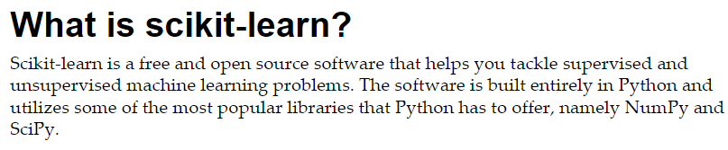

Pg.7

Pg.14

Pg.14

## Implementing knn algorithm

Pg.23

Pg.23

Pg.24

Pg.24

## Explanation overfitting / underfitting

Pg.25

pg.25

## Scaling for performance

Pg.27

Pg.28

## Predicting Numeric Outcomes with Linear Regression

Pg.52

# Learning Scikit-learn : Machine Learning in Python: Experience the Benefits of Machine Learning Techniques by Applying Them to Real-world Problems Using Python and the Open Source Scikit-learn Library

Garreta, R. and Moncecchi, G. (2013) *Learning Scikit-learn : Machine Learning in Python: Experience the Benefits of Machine Learning Techniques by Applying Them to Real-world Problems Using Python and the Open Source Scikit-learn Library*. Birmingham, UK: Packt Publishing (Community Experience Distilled). Available at: https://search.ebscohost.com/login.aspx?direct=true&AuthType=ip,sso&db=e000xww&AN=673033&site=ehost-live&scope=site (Accessed: 26 July 2022).

# Mastering Machine Learning with Scikit-learn - Second Edition

Hackeling, G. (2017) *Mastering Machine Learning with Scikit-learn - Second Edition*. Birmingham, UK: Packt Publishing. Available at: https://search.ebscohost.com/login.aspx?direct=true&AuthType=ip,sso&db=e000xww&AN=1562686&site=ehost-live&scope=site (Accessed: 26 July 2022).